6/11/2021

**Report**

**Java Project**

Your Introduction

Name:

Semester:

University:

Department:

**Contents**

**Introduction____________________________________________________________________ 03**

**Working ______________________________________________________________________ 03**

**Use Case Diagram ______________________________________________________________ 04**

**UML Diagram _________________________________________________________________ 04**

**Outputs ______________________________________________________________________ 05**

**Introduction:**

This is drawing application which is developed **by OOP concepts (Inheritance, Polymorphism, Abstraction, Generic concepts).** Basically this application is used to draw basic shapes like Circle, Rectangle, Square and a Straight line. By using this app, you can also fill color in a shape, resize a shape, delete a shape, and you can also drag and drop a shape. This App is based **on MVC (Model View Controller)** and **Memento** pattern.

**Working**

This App is basically 100% based on Object Oriented.

We have a main Single parent Model Called Shape and all other models or children classes are inherits Shape class which is an abstract class.

On the other hand we have Controller, this Controller contains an Object of View and also an Object of Shape

When we have to draw any shape on an Pane We just call a method UpdateView().

And the third thing is View. View Contains A class that updates and handle undo and redo functions and other classes helps it according to momento pattern.

Some other explanations:

A pane opens on the right side of the screen when user clicks on some shape. When a user right clicks on a specific shape whole lot of options come into play.

It allows user to perform specific functions such as:

* Draw a shape
* Fill color into the shapes
* Delete a shape
* Resize a shape
* Copy paste a shape
* Drag a shape

Design Pattern:

* MVC
* Momento Design Pattern
* Factory Design Pattern
* Strategy Design Pattern

These patterns can be applied on the

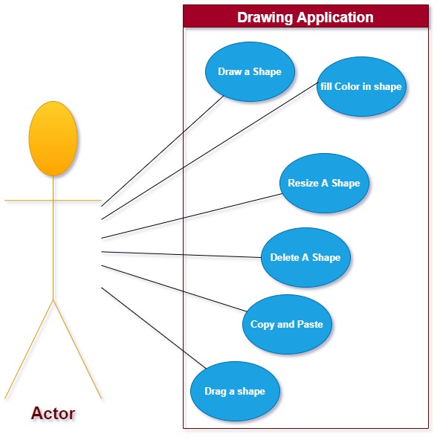Use Case UML:

**UML Class Diagram**

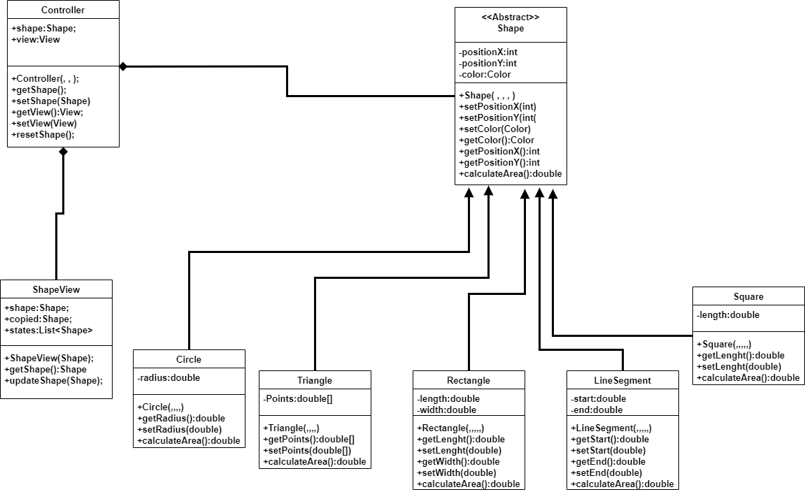

Outputs:

1. 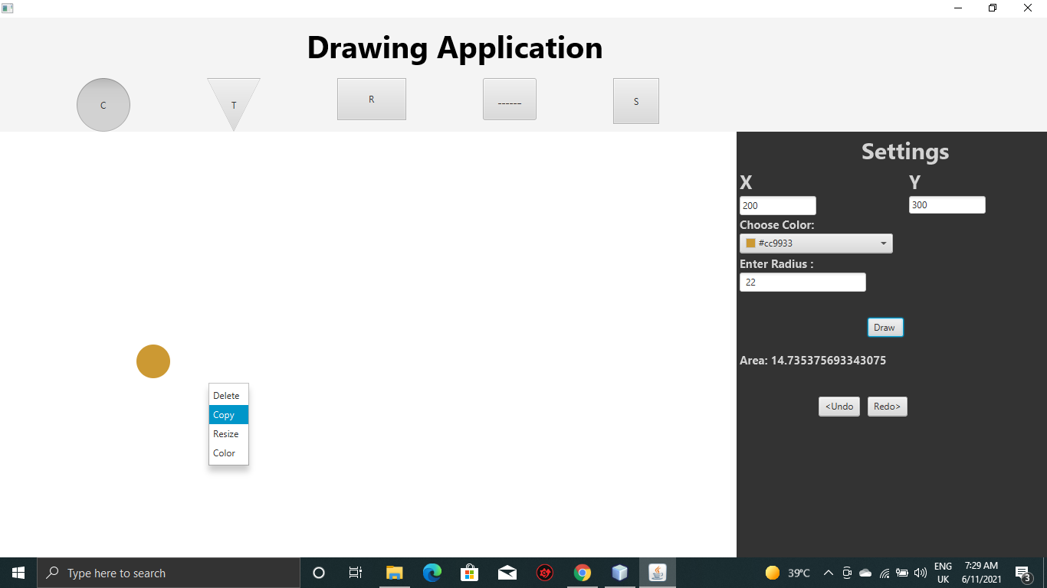I have drawn a small circle with a color fill.
2. 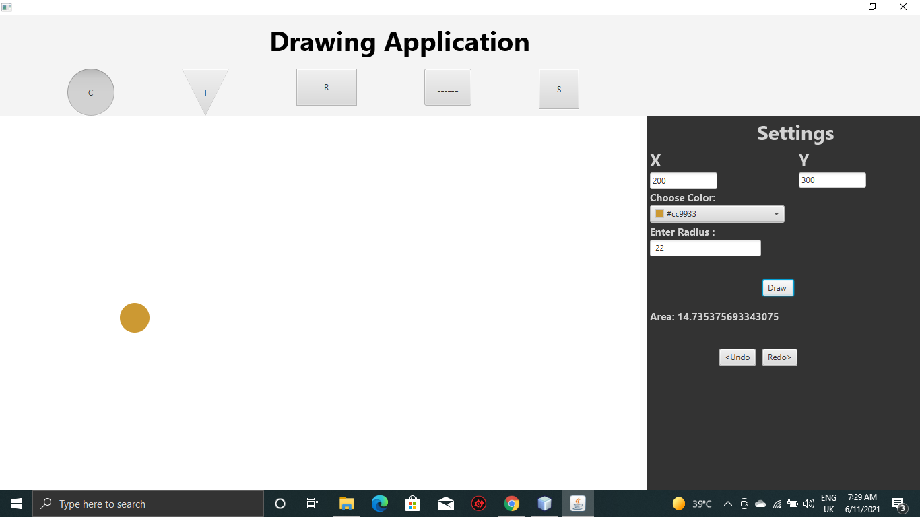Now I have copy this small circle.
3. 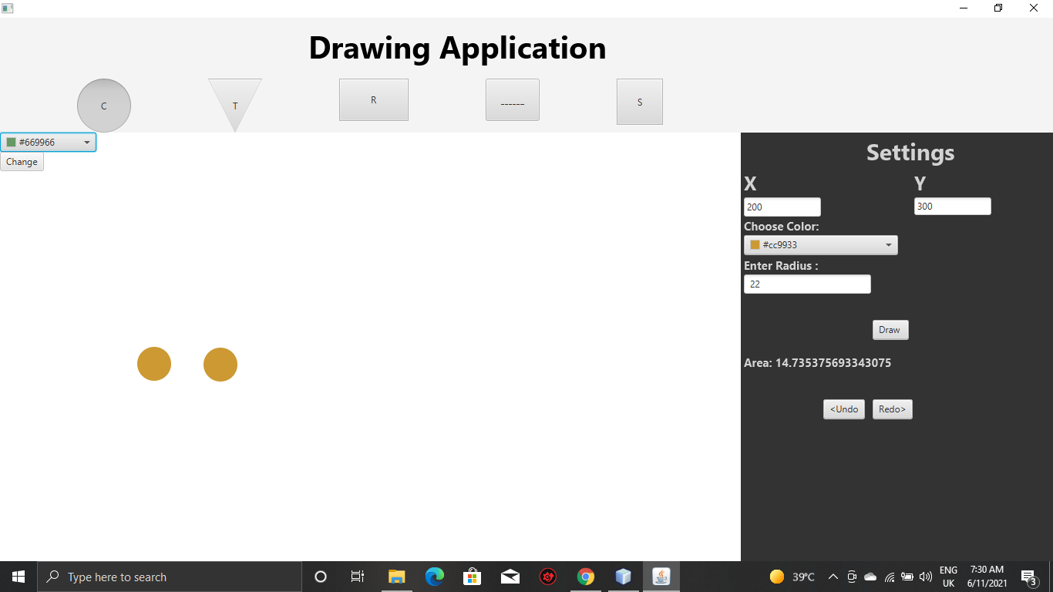Now I have paste this small circle.
4. 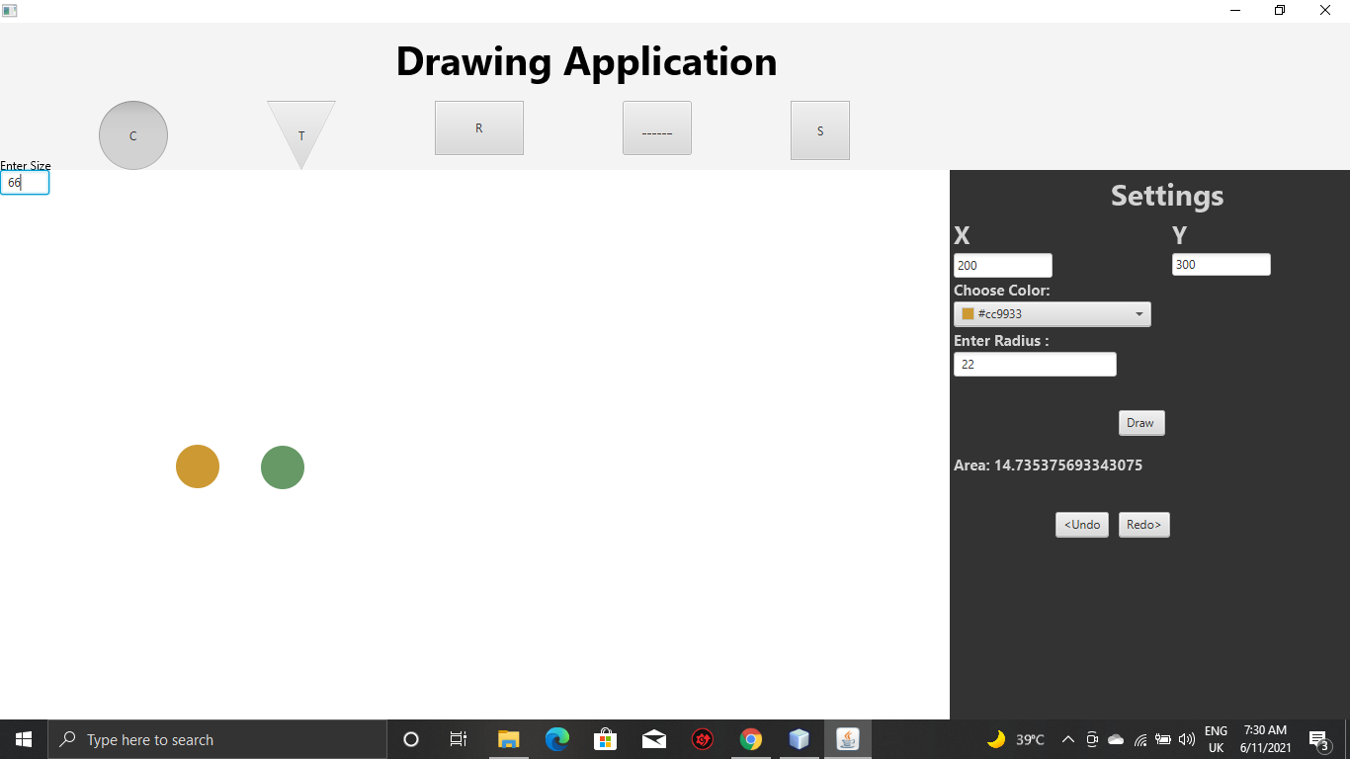Change the color of pasted circle.
5. 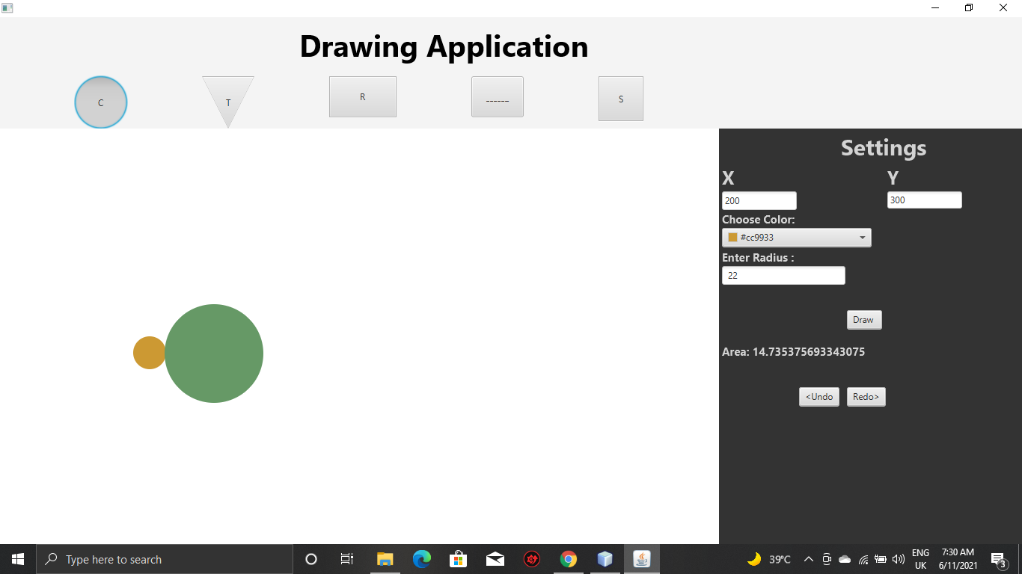Resizing of pasted circle.

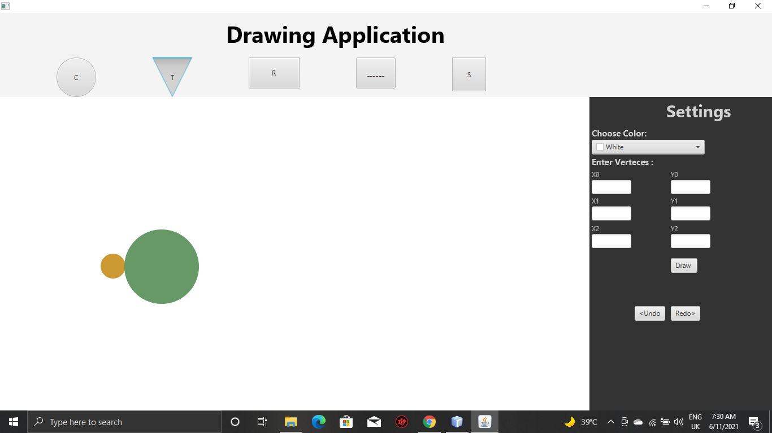

1. 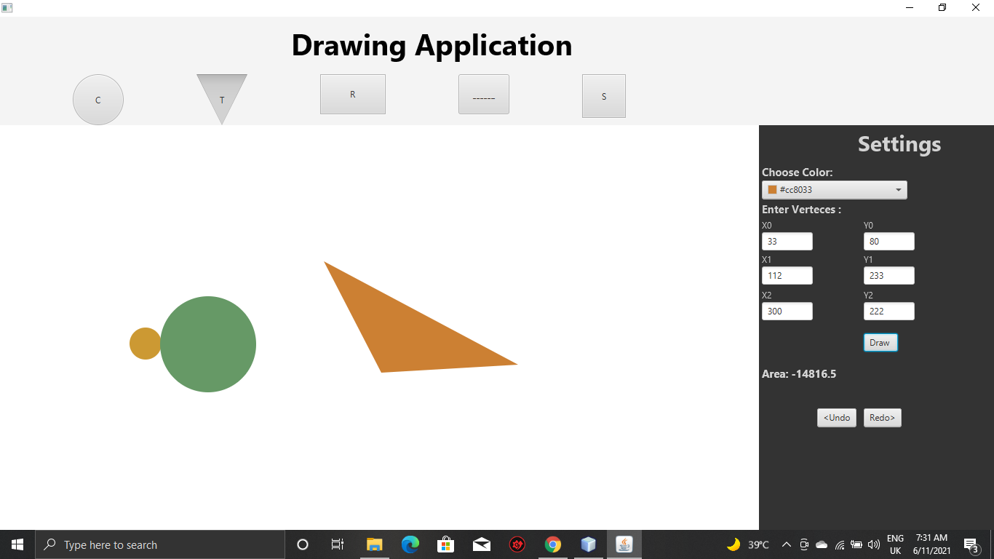Now, I have new shape i.e. Triangle with color fill.
2. 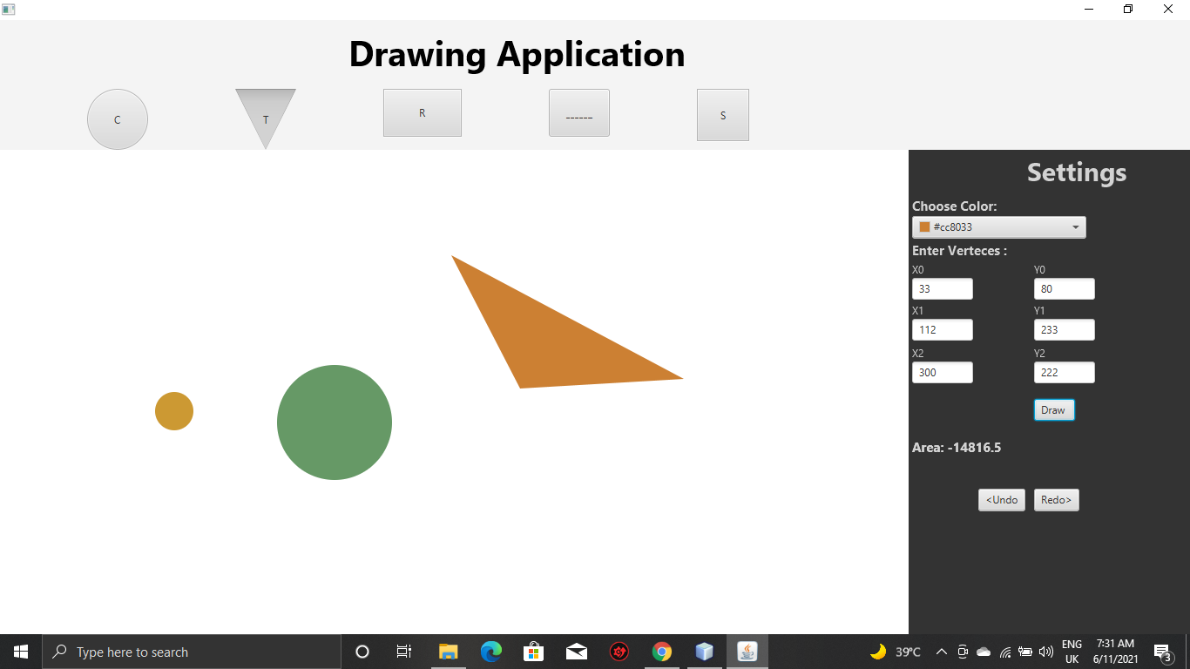Now I have Drag and drop these shapes.
3. 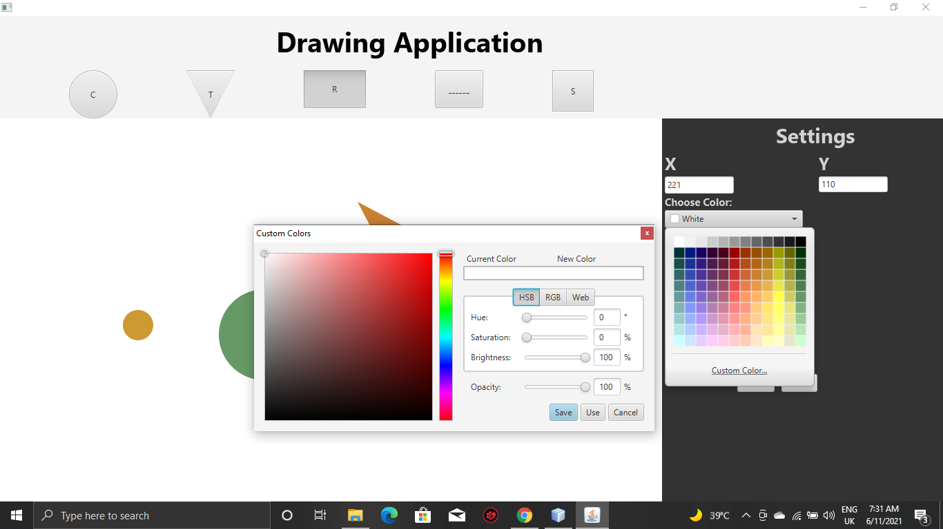Changing the color of Shapes.
4. 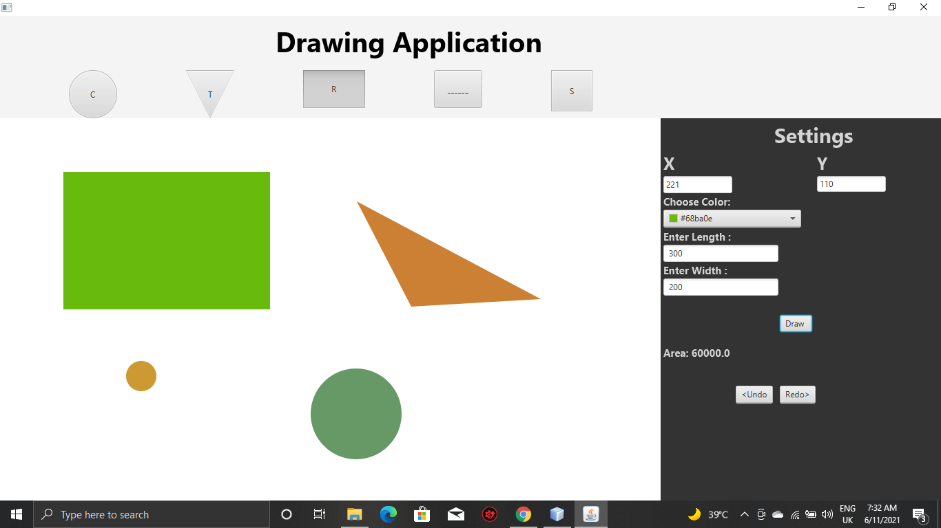Now, I have new shape i.e. Rectangle with color fill.

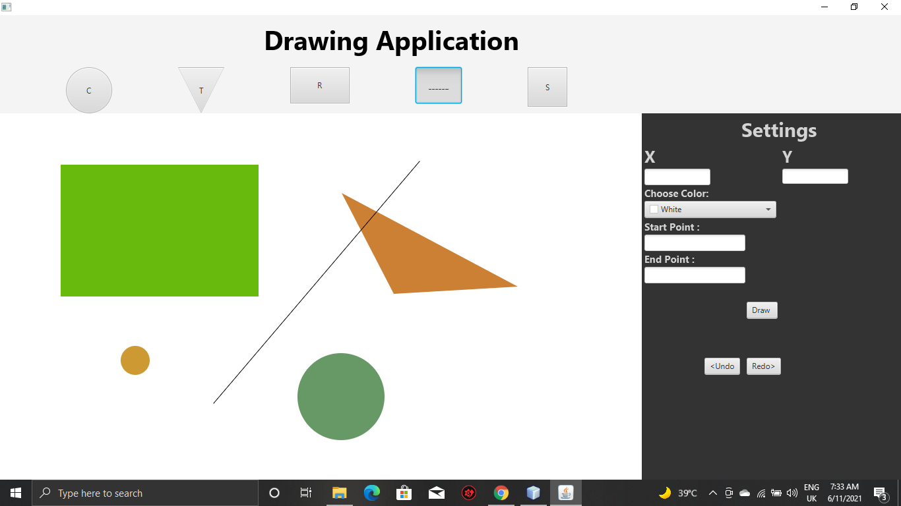10- Now, I have new shape i.e. Straight Line with color fill

11-Now I have Drag and drop these shapes.

